Computer Language Coding Concepts

Sub-Commands in a Diagram
The concept of sub-commands was already explained in the article Sub-Commands. The current article demonstrates the concept in a diagram.

Sub-commands are contained inside a parent command. You will see them in both active and inactive commands symbols. The sub-commands themselves, are either command calls or active clauses.

Below is a picture of two sub-commands inside an inactive command:

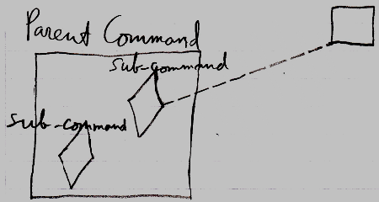

The Parent Command is an inactive command, because it is a square. An inactive command is either a command definition or an inactive clause. In the diagram above, the Parent Command contains two sub-commands. The sub-commands are displayed as diamond shapes. One of the sub-commands is a call, because it has a line going outside the Parent Command, tying the sub-command to its command definition. The other sub-command is an active clause, because it does not redirect its command definition.

Below is a picture of two sub-commands inside a command execution:

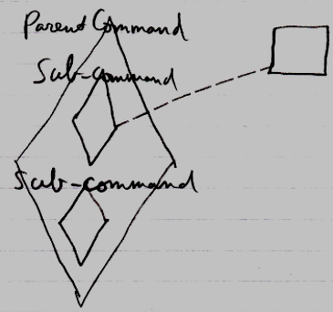

It is the same picture as the other diagram, only now the Parent Command is a command execution, not an inactive command.

(You may be wondering, what assigns the class line of the displayed command call. This is covered in completely different articles, but I will briefly explain it here. The class redirection is defined in the parent command’s command definition. The class redirection is taken over from parent command’s command definition when the parent command is created. If the parent command is a clause, then the class redirection is defined by the command definition holding the clause.)

See also: Sub-Commands, Commands, Active Clause in a Diagram, Command Call in a Diagram

Author & Copyright: Jan-Joost van Zon Date: August 2, 2008 – August 3, 2008 Location: Oosterhout, The Netherlands Status: Finished

